
Register Number

SRM INSTITUTE OF SCIENCE AND TECHNOLOGY
Set - A
SRM Nagar, Kattankulathur – 603203, Chengalpattu District, Tamil Nadu
College of Engineering and Technology
School of Computing
Department of Data Science and Business Systems
Academic Year: 2023-24 (Odd)

Test | : CLA-T3 | Date | : 02-11-2023
Course Code & Title | : 18CSE487T – Data warehousing and Its  Applications | Duration | : 90 Minutes
Year & Sem | : III&IV Year /V& VII Sem | Max Marks | : 50

Course Articulation Matrix:
S.No. | Course Outcome | PO1 | PO2 | PO3 | PO4 | PO5 | PO6 | PO7 | PO8 | PO9 | PO10 | PO11 | PO12 | PO13 | PO14 | PO15
1 | CO1 | 3 | - | - | - | - | - | - | - | - | - | - | - | - | - | -
2 | CO2 | 3 | - | - | - | - | - | - | - | - | - | - | - | - | - | -
3 | CO3 | 3 | - | - | - | - | - | - | - | - | - | - | - | - | - | -
4 | CO4 | 3 | - | - | - | - | - | - | - | - | - | - | - | - | - | -
5 | CO5 | 3 | - | - | 3 | - | - | - | - | - | - | - | - | - | - | -
6 | CO6 | 3 | - | - | - | - | - | - | - | - | - | - | - | - | - | -

Part - A
(5 x 1 = 5 Marks)
Instructions: Answer all
Q. No | Question | Marks | BL | CO | PO | PI Code
1 | Which of the following process uses intelligent methods to extract data patterns?  a) Data mining  b) Text mining  c) Warehousing  d) Data selection | 1 | L1 | 4 | 1 | 1.6.1
2 | In Apriori algorithm, the Frequency of occurrence of an itemset is called _____  a) Support  b) Confidence  c) Support Count  d) Rules | 1 | L2 | 4 | 1 | 1.6.1
3 | The data (red, blue, green) are ___________  a) Nominal  b) Ordinal  c) Continuous  d) Discrete | 1 | L2 | 4 | 1 | 1.6.1
4 | 14) Which one of the clustering techniques needs the merging approach?  a) Partitioned  b) Naïve Bayes  c) Hierarchical  d) Decision tree | 1 | L2 | 4 | 1 | 1.6.1
5 | What is the main advantage of decision trees?  a) Easy to interpret and visualize  b) Handles non-linear relationships well  c) Requires minimal training data  d) Provides high precision without overfitting | 1 | L1 | 4 | 1 | 1.6.1
Part – B
( 3 x 5 = 15 Marks)
Answer ANY THREE Questions
6 | Explain the K-means clustering with a suitable example | 5 | L2 | 4 | 1 | 1.6.1
7 | How the conditional probability is used in Naïve Bayes classification? | 5 | L1 | 4 | 1 | 1.6.4
8 | What are the different types of data? Give suitable examples for all types of data. | 5 | L1 | 4 | 1 | 1.6.4
9 | Write about multi-dimensional association rules. | 5 | L1 | 5 | 1 | 1.6.1
Part – C
( 3 x 10 = 30 Marks)
Answer ANY THREE Questions
10 | Explain the Apriori algorithm with suitable example. | 10 | L3 | 4 | 1 | 3.2.2
(or)
11 | Explain in detail the support vector machine. | 10 | L1 | 4 | 1 | 1.6.4
12 | Explain in detail data warehousing concepts for the Tamilnadu Government | 10 | L3 | 5 | 1 | 1.6.4
(or)
13 | Explain in detail data warehousing concepts for the Andhra Pradesh Government | 10 | L1 | 6 | 1 | 1.6.4
14 | Explain in detail about text mining with spatial data mining and temporal data mining. | 10 | L1 | 6 | 1 | 1.6.1
(or)
15 | Write about various data mining applications. | 10 | L2 | 4 | 1 | 1.6.4

Course Outcome (CO) and Bloom’s level (BL) Coverage in Questions

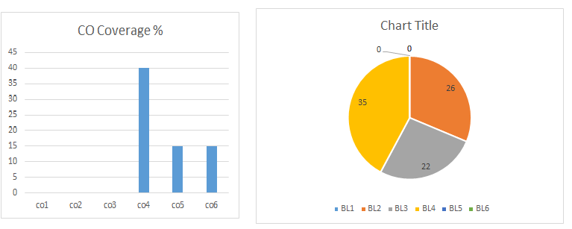

Approved by the Audit Professor/Course Coordinator

